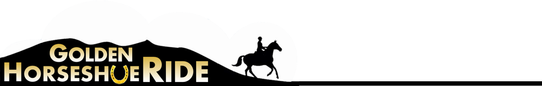
RIDER SPONSORSHIP FORM

Once again this year, we are asking for your financial help for the ride, by asking you to approach your local tack shop, feed supplier, farrier or other company to make a small donation to the Ride and they will receive, in return, an acknowledgement in the Golden Horseshoe Ride Programme. For a simple acknowledgement of their sponsorship for a particular rider the cost is £15 or, alternatively, they may wish to take out a Half Page (£20) or Full Page (£30) advertisement (black & white) or Full Page colour advertisement (£50).
If you would like a link to your own website, we shall be happy to include this on our Links page – the cost for this is £10 per link.
There is no limit to the number of sponsors any one rider/horse may have!
Please send your sponsor forms/advertisement copy or requests for a website link to:
Jo Chisholm, Higher Watervale Farm, Lydford, Okehampton, Devon EX20 4AL
Email: ghs@mapmarketing.com
The copy deadline for these sponsorships is 6th May to ensure inclusion in the ride programme. However, if it is later than this date, please contact Jo directly as it may still be possible to include your sponsorship.

SAMPLE

Spanish Diablo ridden by Mary Mortimer is sponsored by:

Fourways Veterinary Surgery
catering for the needs of both small and large animals.
For further information phone 01986 397234

We wish Mary all the best for Golden Horseshoe and the Endurance season!

SPONSOR FORM

…….……………………………..…………. ridden by ………………………………………………

is sponsored by

…………………………………………………...……………………………………………………………

………………………………………………………………………………………………………………..

…………………………………………………...……………………………………………………………

………………………………………………………………………………………………………………..

………………………………………………………………………………………………………………..

Please make your cheque payable to “Endurance GB”

